To study reverse Kinematics of 2 dof planer serial manipulator
Exp
No 4

Aim: To study reverse Kinematics of 2 dof planer serial manipulator

Instrument required: Desktop PC with internet connection.

Inverse Kinematics:
Inverse kinematics (IK) in robotics is the mathematical process of calculating required joint angles and parameters to position a robot's end-effector (gripper, tool) at a specific Cartesian coordinate and orientation. It is the reverse of forward kinematics, allowing robots to move to desired locations

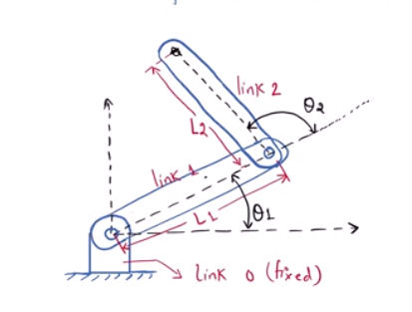
Derive the closed form IK of this 2 Dof manipulator.

Given Equation:

$${}_{2}^{0}{T = {}_{1}^{0}T} x {}_{2}^{1}T$$
Configuration Matrix:
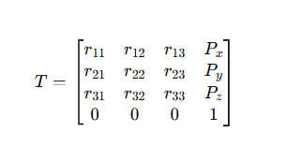
Configuration matrix for above manipulator for theta1 =0 and theta2 = 0

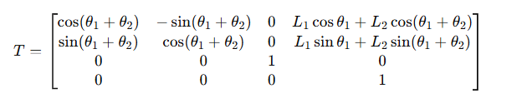
Equating general equation with manipulator equation:
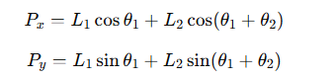
Solve for theta2:

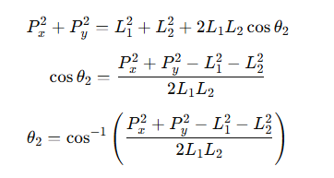
For theta1:
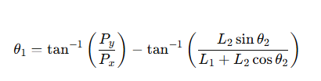

Matlab Code:
clc;
clear;
Px = 9.1416; % end effector x
Py = 14.7984; % end effector y
L1 = 10; % link1 length
L2 = 8; % link2 length

D = (Px^2 + Py^2 - L1^2 - L2^2)/(2*L1*L2);

theta2 = atan2(sqrt(1-D^2), D);

theta1 = atan2(Py, Px) - atan2(L2*sin(theta2), L1 + L2*cos(theta2));

disp('Theta1 =')
disp(theta1)

disp('Theta2 =')
disp(theta2)

Answer:
Theta1 =
0.7854
Theta2 =
0.5236

Result:

